**ITEC301 DELIVERABLE 2**

**DOCUMENTATION AND CODING**

|  |  |
| --- | --- |
| **Student Name:** | **Anthony Shepherd** |
| **Student Number:** | **DQXF8H5N9** |
| **Project Title:** | **Candy Land** |
| **Submission Date:** | **2021/06/26** |

Contents

2.1 Introduction 3

2.2 Prototyping 3

Prototype A: 3

Prototype B: 5

2.3 Designing 6

Class Responsibility Collaborator (CRC) cards 6

Enhanced Entity Relationship Diagram (EERD) 6

Context Diagram 6

Data Flow Diagram (DFD) 7

Use Case Diagram 7

Database Design 7

2.4 Coding 8

Screenshots 8

Php Code 10

HTML Code 11

JavaScript Code 12

CSS Code 13

MySQL Tables 14

2.5 Conclusion 15

2.6 Sign-off 15

# 2.1 Introduction

This document contains all the design documents for Candy Lands E-commerce website, in addition to screen shots of what the product will look like and sample code.

# 2.2 Prototyping

## Prototype A:

## Prototype B:

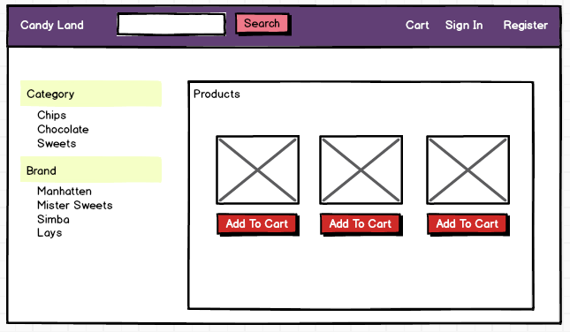 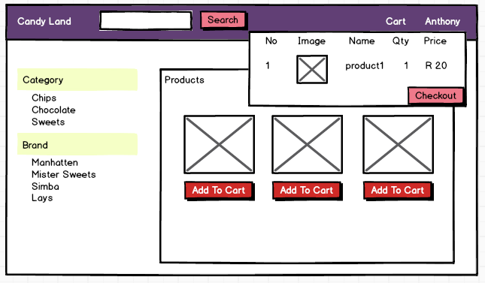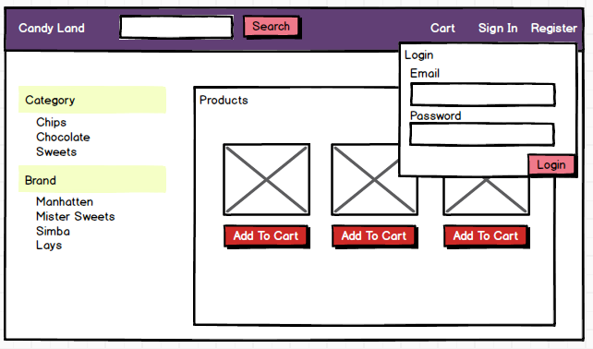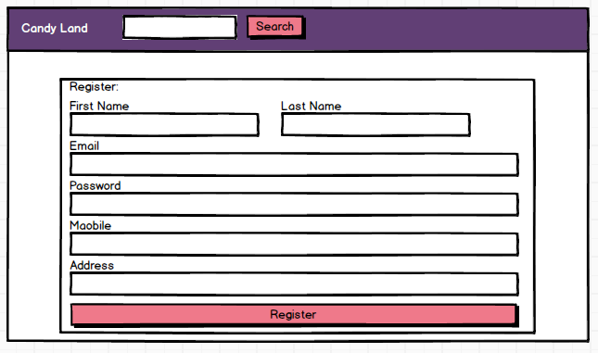

# 2.3 Designing

## Class Responsibility Collaborator (CRC) cards

## Enhanced Entity Relationship Diagram (EERD)

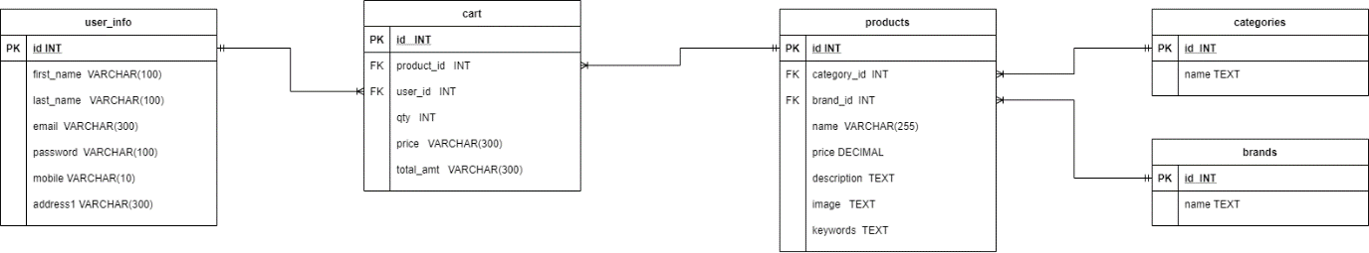

## Context Diagram

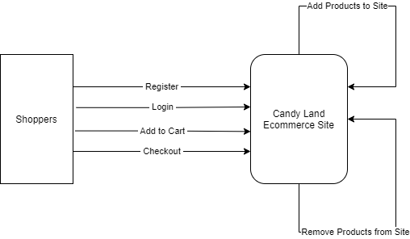

## Data Flow Diagram (DFD)

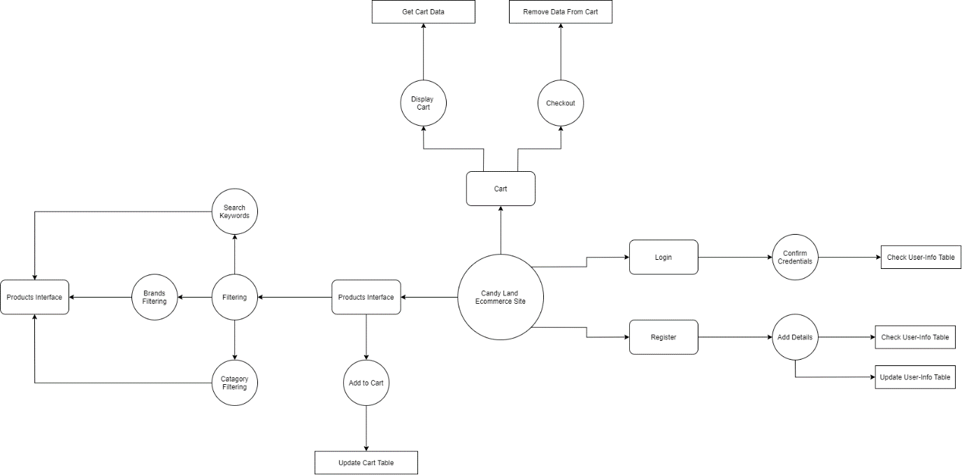

## Use Case Diagram

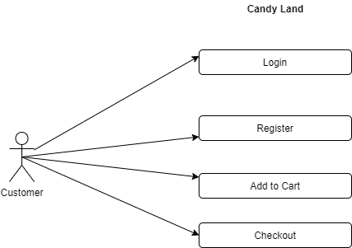

## Database Design

# 2.4 Coding

## Screenshots

Register Screen

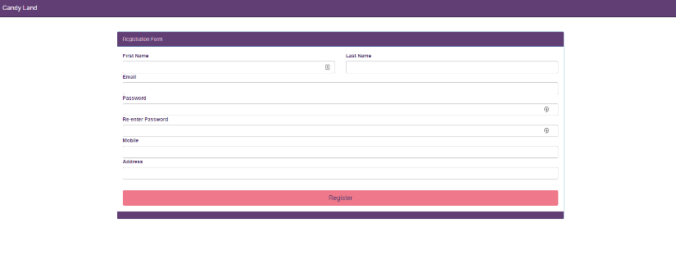

Cart

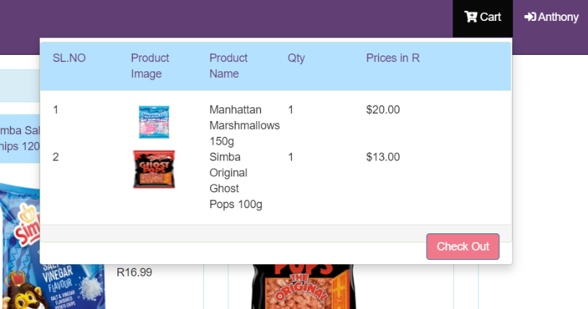

Login

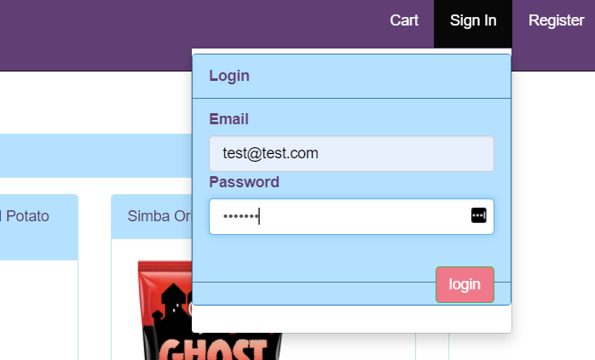

Main: Logged In

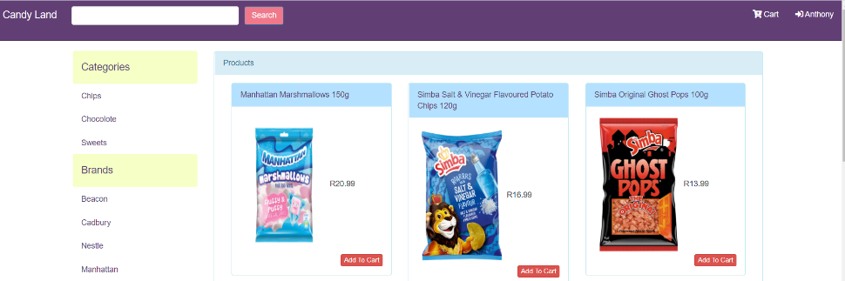

Main: Logged Out

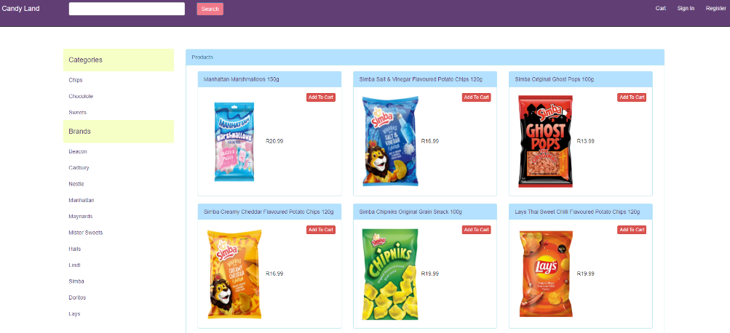

Files

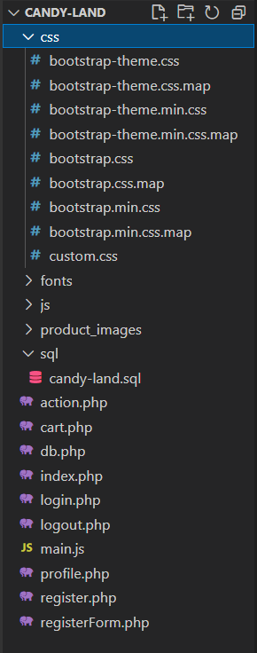

## Php Code

The below screenshots are of the action.php file, this file has the main functions for populating the products, categories and brands as well as saving user info.

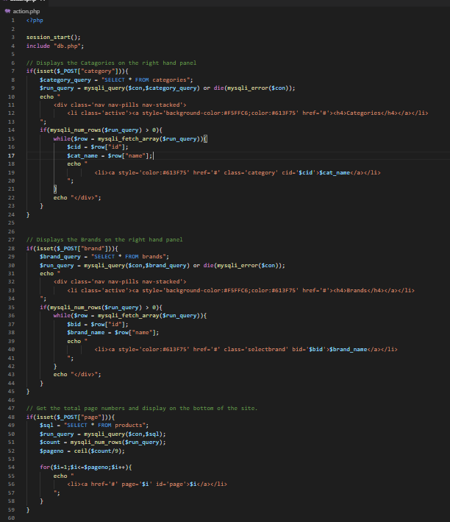 ­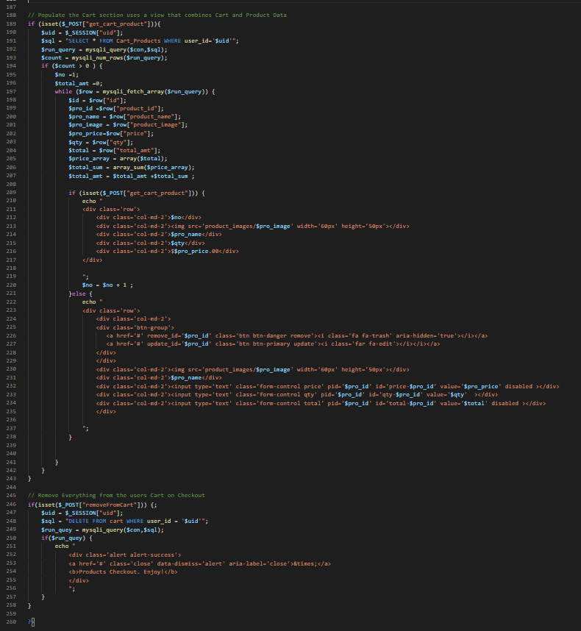

## HTML Code

The html in the screenshots below is of the index.php file it is the main html file for the Candy Land website.

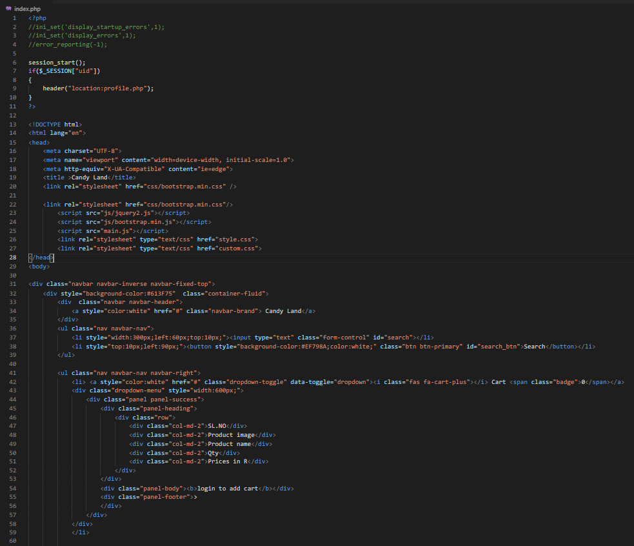 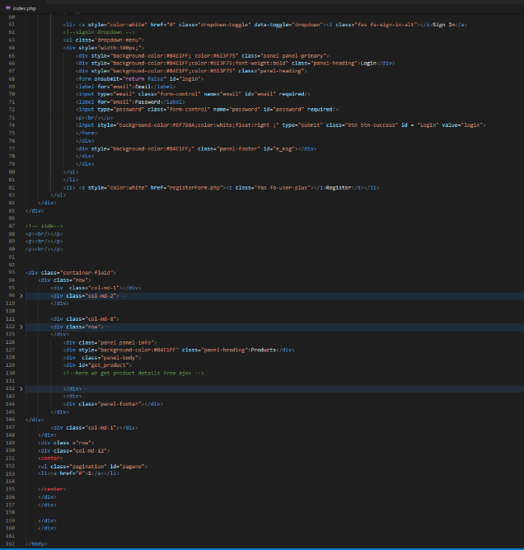

## JavaScript Code

The main.js file contains all the JS functions used throughout the website.

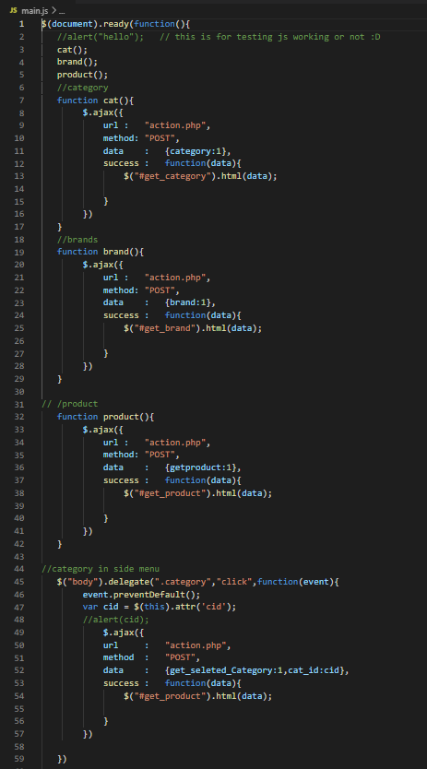 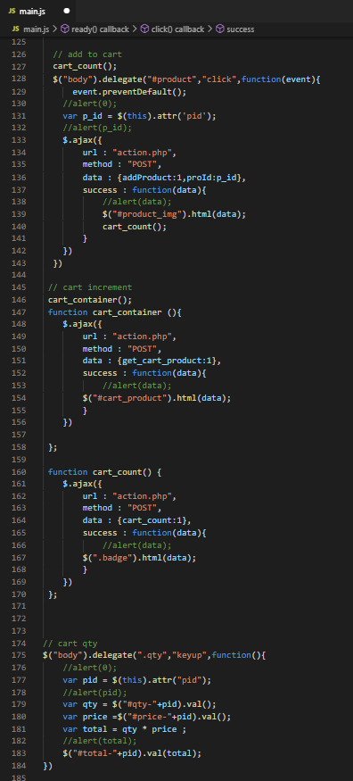

## CSS Code

I used bootstraps default styles for most of the styling and then inline styling when I needed to personalize it according to my design.

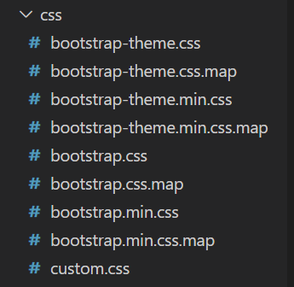

## MySQL Tables

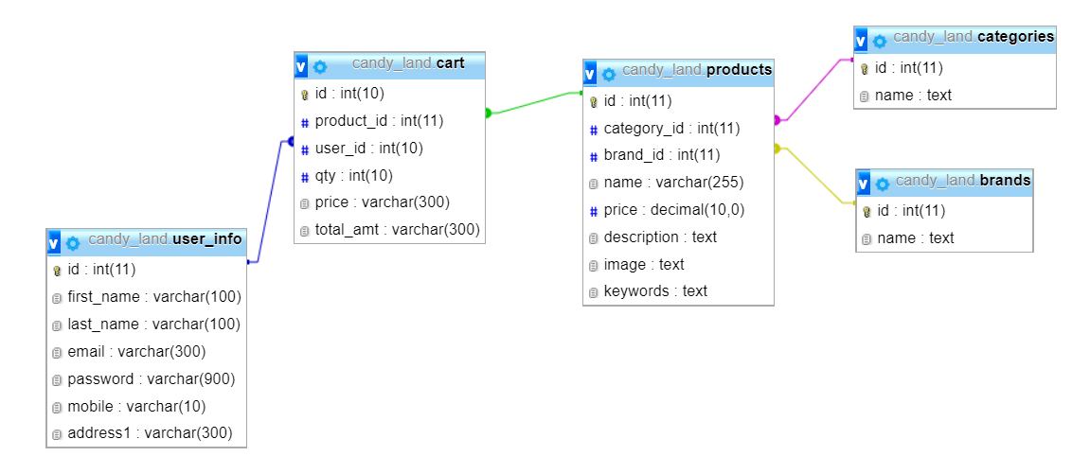

# 2.5 Conclusion

# 2.6 Sign-off

|  |  |  |  |
| --- | --- | --- | --- |
|  |  |  |  |
| [Name], Project Client  Date: _____________________ |  |  | [Name], Project Manager  Date: _____________________ |